Project 1 report
Control table:
Control table is very important in the design, it shows different control signals will let module in Datapath have different functions, the control table is below:

operation | MUX1 | MUX2 | MUX3 | MUX4 | MUX5 | MUX6 | MUX7 | MUX8 | MUX9 | ctr | MUX10 | 0 | 0
ADD | 0 | 1 | 0 | 0 | 1 | 1 | 1 | 0 | 0 | 0101 | 0 | 0 | 0
ADDI | 0 | 0 | 0 | 0 | 1 | 1 | 1 | 0 | 0 | 0101 | 0 | 0 | 0
SUB | 0 | 1 | 0 | 0 | 1 | 1 | 1 | 0 | 0 | 1001 | 0 | 0 | 0
SUBI | 0 | 0 | 0 | 0 | 1 | 1 | 1 | 0 | 0 | 1001 | 0 | 0 | 0
CMP | 0 | 1 | 0 | 0 | 1 | 1 | 1 | 0 | 0 | 1011 | 0 | 0 | 0
CMPI | 0 | 0 | 0 | 0 | 1 | 1 | 1 | 0 | 0 | 1011 | 0 | 0 | 0
AND | 0 | 1 | 0 | 0 | 1 | 1 | 1 | 0 | 0 | 0001 | 0 | 0 | 0
ANDI | 0 | 0 | 0 | 0 | 1 | 1 | 1 | 0 | 0 | 0001 | 0 | 0 | 0
OR | 0 | 1 | 0 | 0 | 1 | 1 | 1 | 0 | 0 | 0010 | 0 | 0 | 0
ORI | 1 | 0 | 0 | 0 | 1 | 1 | 1 | 0 | 0 | 0010 | 0 | 0 | 0
XOR | 0 | 1 | 0 | 0 | 1 | 1 | 1 | 0 | 0 | 0011 | 0 | 0 | 0
XORI | 1 | 0 | 0 | 0 | 1 | 1 | 1 | 0 | 0 | 0011 | 0 | 0 | 0
MOV | 0 | 1 | 0 | 0 | 1 | 1 | 1 | 0 | 0 | 1101 | 0 | 0 | 0
MOVI | 1 | 0 | 0 | 0 | 1 | 1 | 1 | 0 | 0 | 1101 | 0 | 0 | 0
LSH | 0 | 1 | 0 | 0 | 1 | 1 | 1 | 0 | 0 | 0100 | 0 | 0 | 0
LSHI | 0 | 0 | 0 | 0 | 1 | 1 | 1 | 0 | 0 | 0100 | 0 | 0 | 0
ASH | 0 | 1 | 0 | 0 | 1 | 1 | 1 | 0 | 0 | 0110 | 0 | 0 | 0
ASHI | 0 | 0 | 0 | 0 | 1 | 1 | 1 | 0 | 0 | 0110 | 0 | 0 | 0
LUI | 0 | 0 | 0 | 1 | 1 | 1 | 1 | 0 | 0 | 1111 | 0 | 0 | 0
LOAD | 0 | 1 | 0 | 1 | 1 | 0 | 1 | 0 | 0 | 0111 | 1 | 0 | 0
STORE | 0 | 1 | 0 | 0 | 1 | 0 | 0 | 0 | 0 | 1010 | 0 | 0 | 0
JAL | 0 | 0 | 0 | 0 | 0 | 1 | 1 | 1 | 1 | 1000 | 0 | 0 | 0
Jcond | 0 | 1 | 0 | 0 | 0 | 1 | 1 | 1 | 0 | 0000 | 0 | 0 | 0
NOP | 0 | 1 | 0 | 0 | 1 | 1 | 1 | 0 | 0 | 0010 | 0 | 0 | 0
Control Table

In the control table MUX1 is controlled by C0, when it is 0, it means the input Immediately number will be signal extended. When it is 1, it means the input immediately number will be zero extended.

MUX2 is controlled by C1, when it is 0, it means one of the inputs of ALU core will be Immediately number. When it is 1, it means the input of ALU core will be number in register 1.

MUX3 is controlled by C2, at the beginning, I want to use it to control the input is 4bits Immediate number or 4 bits number in register in LSH and ASH operation, but I find the output of MUX2 is Immediately number/ number in register, I just need to operate the output of MUX2 without C2, so I put all of them 0.

MUX4 is controlled by C3, when it is 0, it will send number in register 2 to ALU, Rtarget or MDR. When it is 1, it will send 0 to them, means that enable the output of register 2.

MUX5 is controlled by C4, which means the output Rtarget is enabled or not. MUX6 is controlled by C5, which means the output MAR is enabled or not. MUX7 is controlled by C6, which means the output MDR is enabled or not. MUX8 is controlled by C7, which means the output of ALU core is enabled or not, if Jcond and JAL, we don’t want the result of ALU core go into the register file.

MUX9 is controlled by C8, when it is 0, the result of ALU core will go into the register file. When it is 1, Rlink will go into the register file.

Ctr is used to identified different operation of ALU core.

MUX10 is controlled by C9, when it is 0, the result of ALU module go into the register file. When it is 1, the output of data memory will go into the register file(LOAD).

Datapath Diagram:
With the control signals, the Datapath diagram with MUX is below:
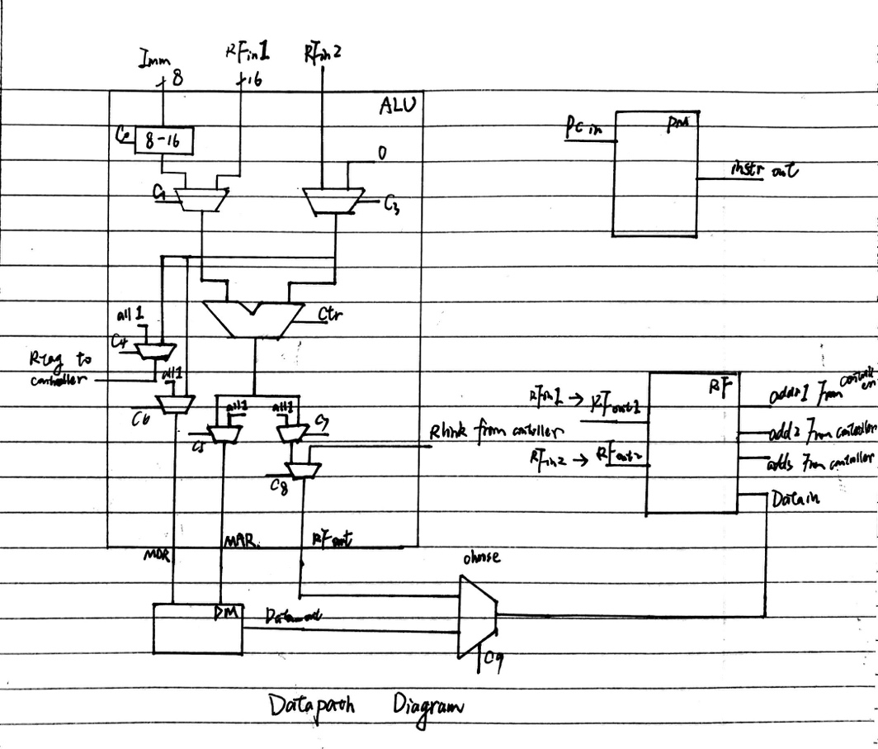
Datapath Diagram
Test:
Generate pc:
All of the operation in the ALU is based on the pc signal, when Jcond and Bcond instruction work, the pc will change in a different way based on Rtarget signal and Displacement signal.
So, I generate the pc as this way:
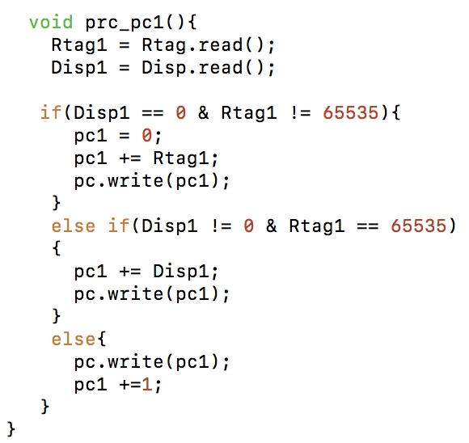
When the Displacement_in and Rtarget_in are “all 1”, the pc will plus 1 in every clock cycle. When Rtarget_in is enabled, the pc will be the number in the Rtarget.
When Displacement_in is enabled, the pc will be the number of pc + Displacement.

Monitor the result:
I use the monitor module to monitor the result, the module function is like this
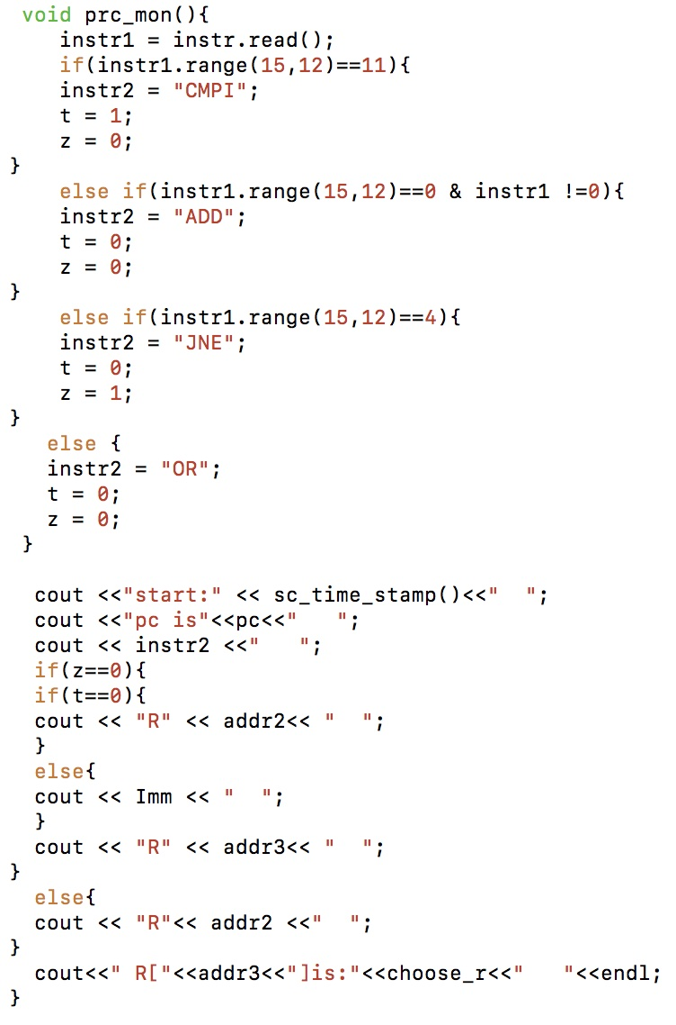
By recoding the instruction signal and the signal send out from the choose module to monitor the result.

Result:
The result of program 1 is:
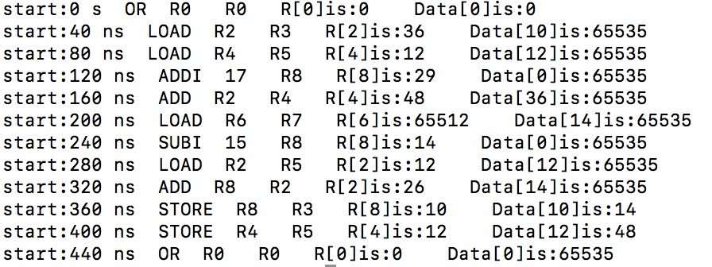
We can see that the result in Register file and Data memory are same as the result in phase 2 requirement. 65535 in Data memory means all 1, which will not record into the Data memory’s memory. 65512 is -24 in <uint> type.

The result of program 2 is:
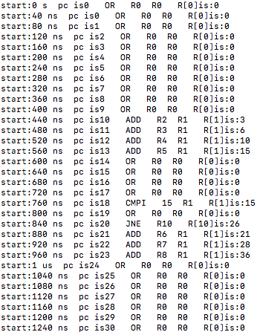
CMPI 15 R1
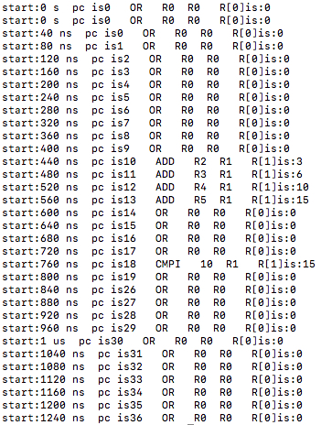
CMPI 10 R1
In R1, the number is 15. So, when Immediately number is 15, the JNE will not work because of the equality of these two numbers. Then pc will plus 1 in every clock cycle and the operation in pc 21-23 will work.

When Immediately number is 10, the JNE will work because of the inequality of these two numbers. Then pc will plus Rtarget and the pc will jump to 26.

Summary:
In the project 1, I am very satisfied of my achievement. Even though it is tough for me to complete it by myself, but I finally get the right result. I met a lot of problems when I test my code, like the problem of clock cycle and the operation in ALU core, but I try my best to solve it and finally they are all solved.

